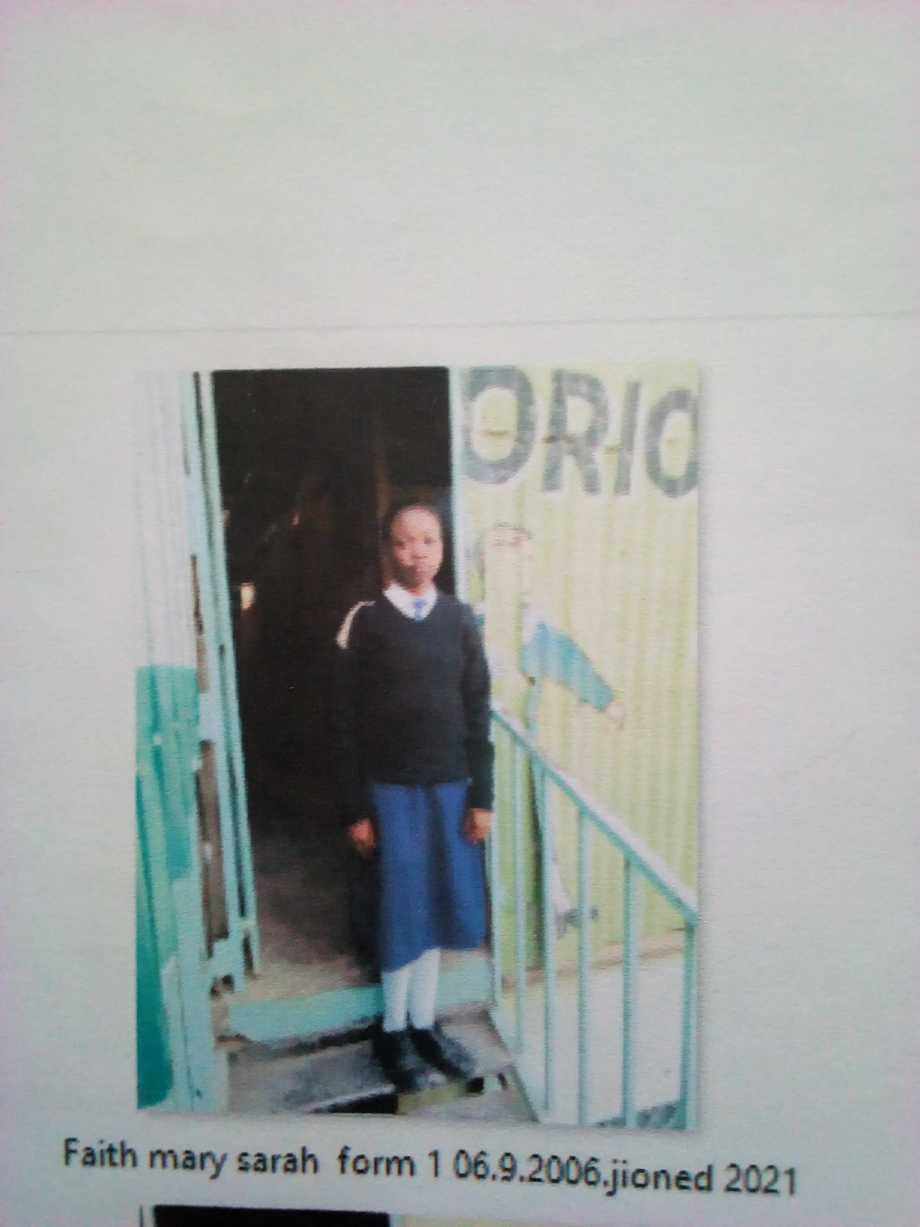 FAITH SARAH MARY FORM 1 BORN 2006 JOINED 2021
Faith 14 years was enrolled in our school when he was 14 years old. Faith is an orphan, her parents died I n a tragic road accident. Faith was left helpless being the only child she was left without anything to count on. She went through primary level by good luck. She sought help from Glorious. After establishing the truth about her situation we resolved to allow him access education.
Thanks to the Director Mr. Boniface Mangeti who allowed Faith in school. I am now learning in glorious at least I have a place I call home praying that one day God will help our school have good classes, toilets and enough study materials. Thank you Michell and Brad for your support have really helped many in Mukuru

